EXERCISE - 11: IMAGE EDITING AND ANIMATION

AIM:

1. Using GIMP, include an image and apply filters, noise and masks.
2. Using GIMP, create a GIF animated image.
3. **INPUT IMAGE: GAUSSIAN BLUR:**

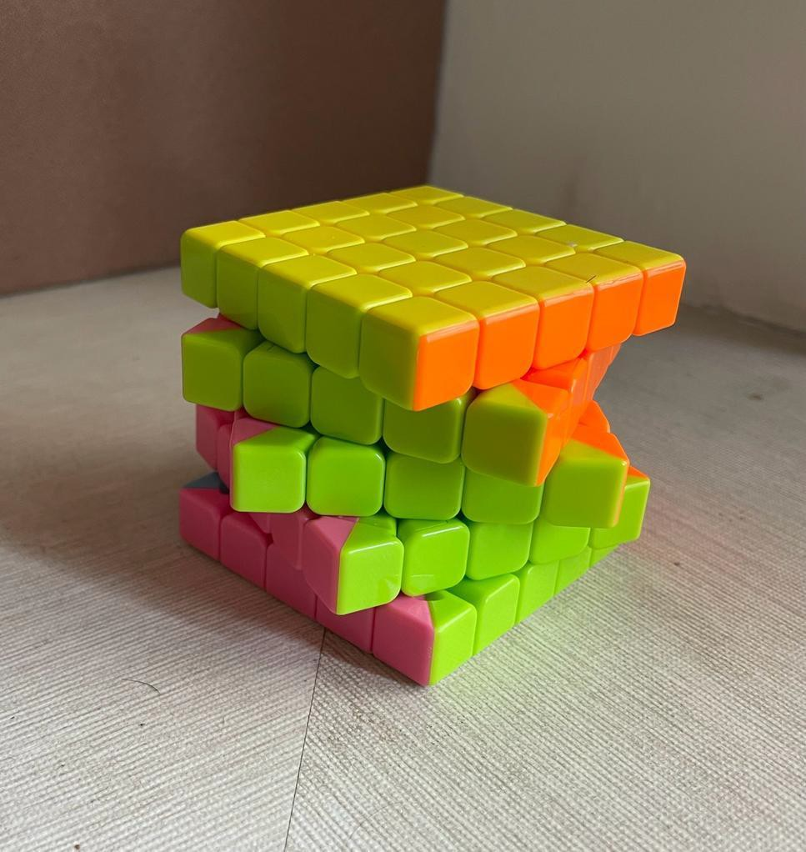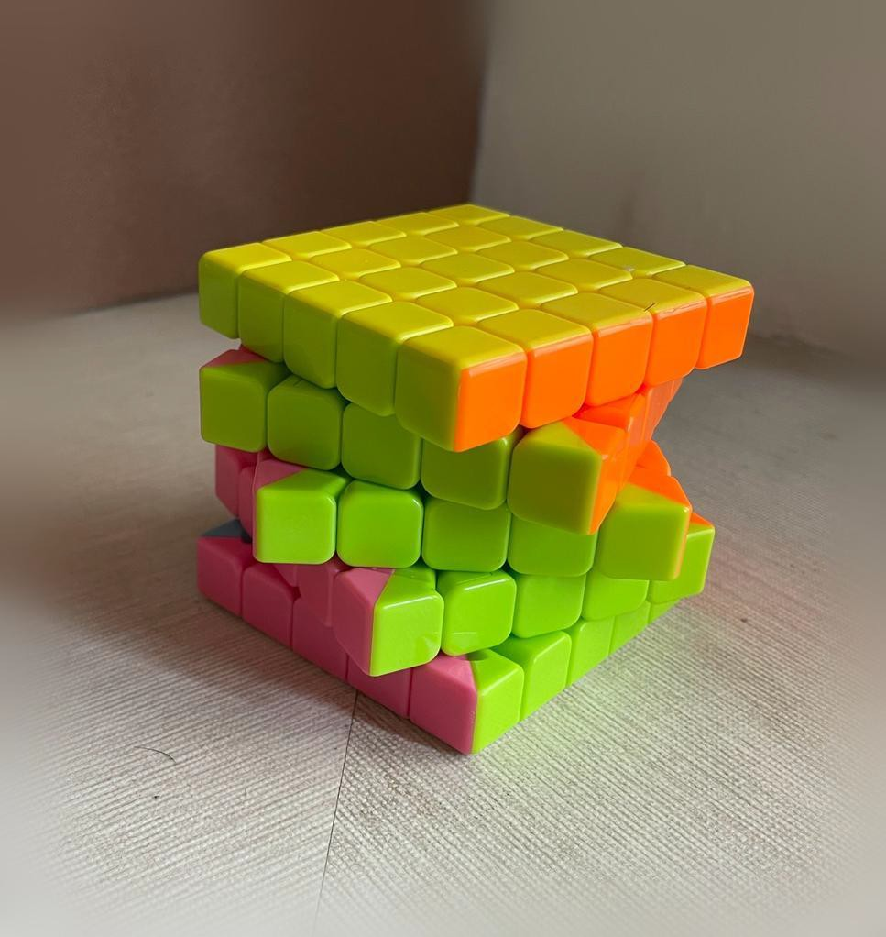

ENHANCED CONTRAST: VIGNETTE:

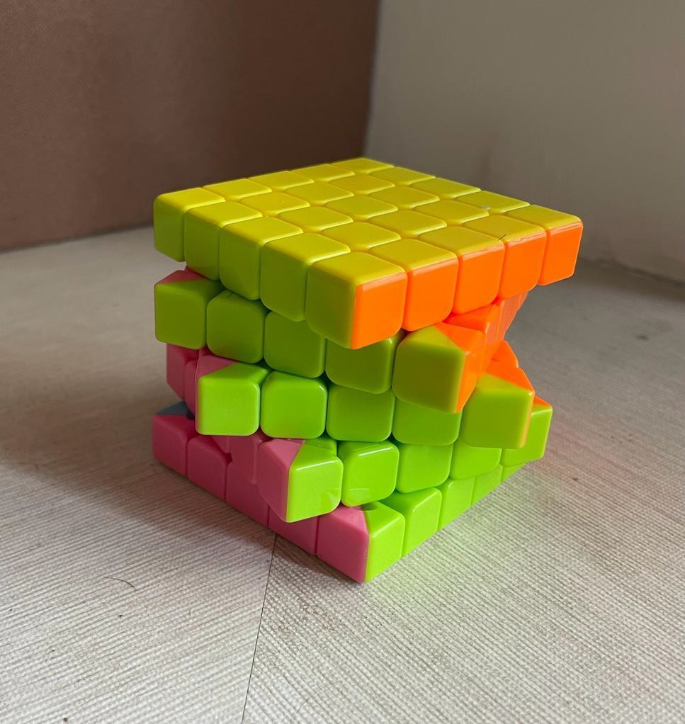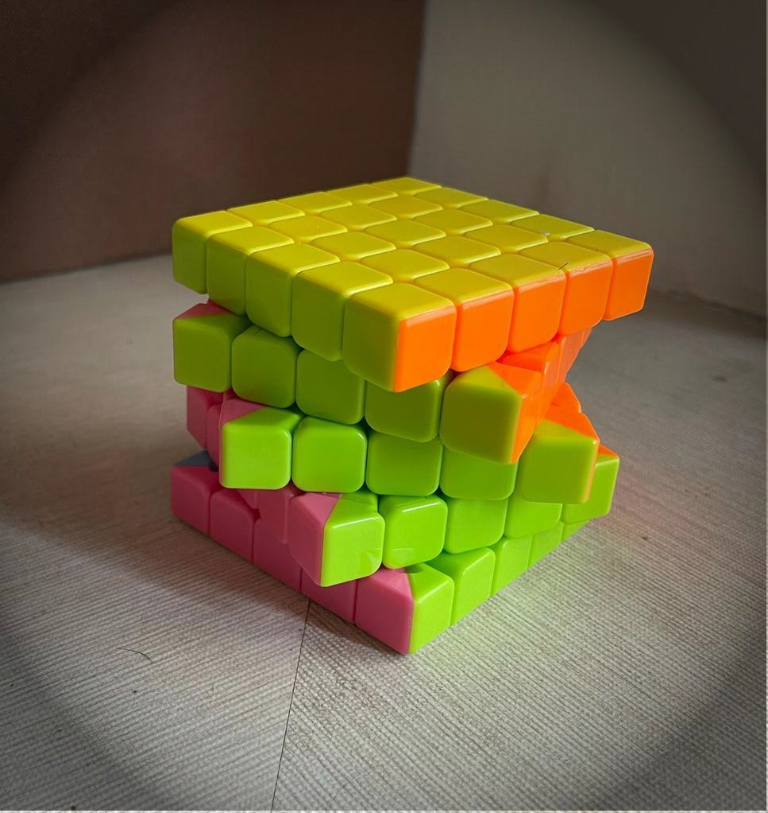

LIGHTING: CARTOON:

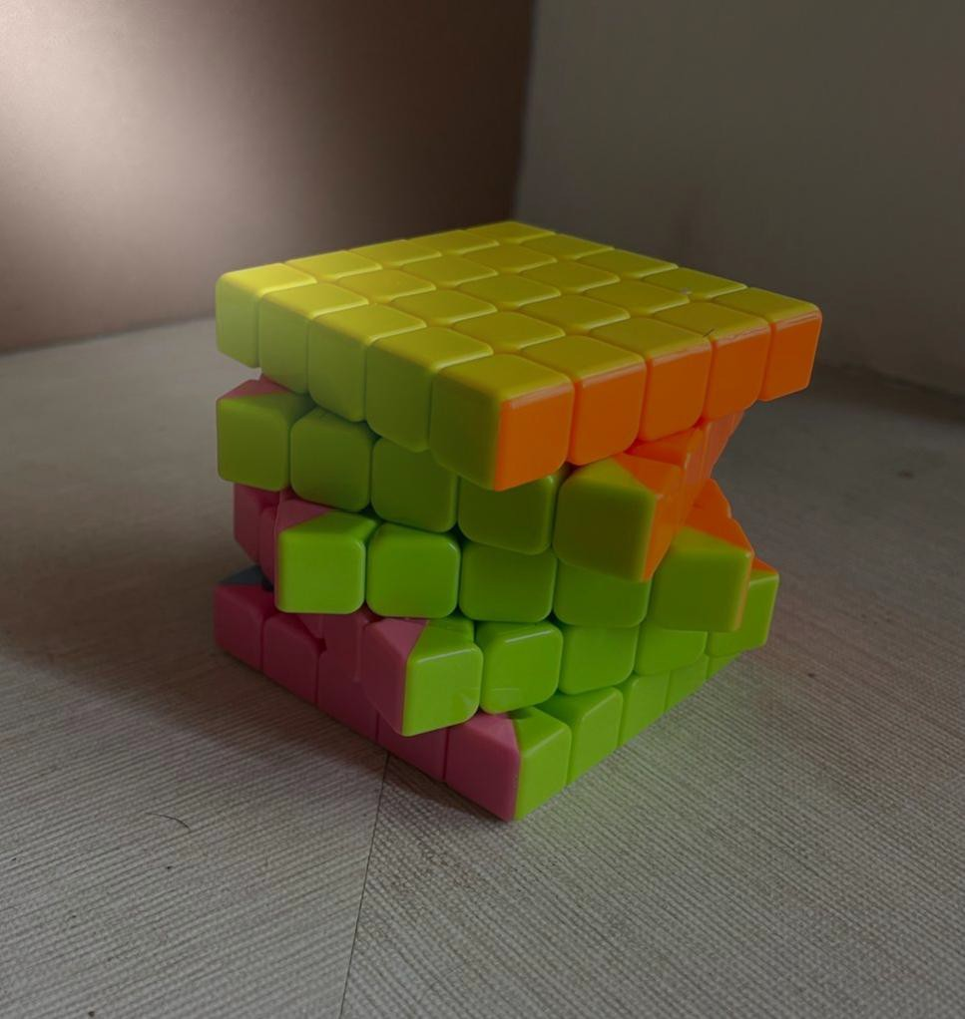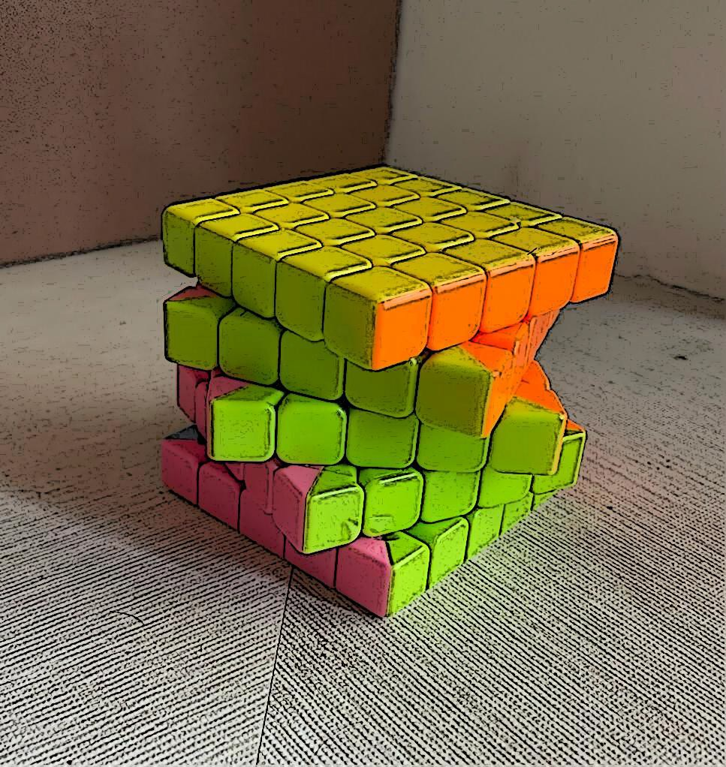

NEON EDGE DETECTION: RGB NOISE:

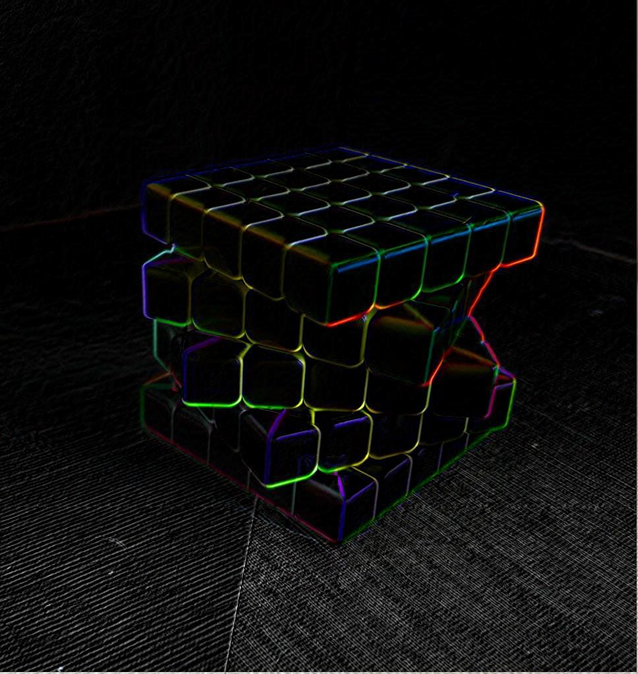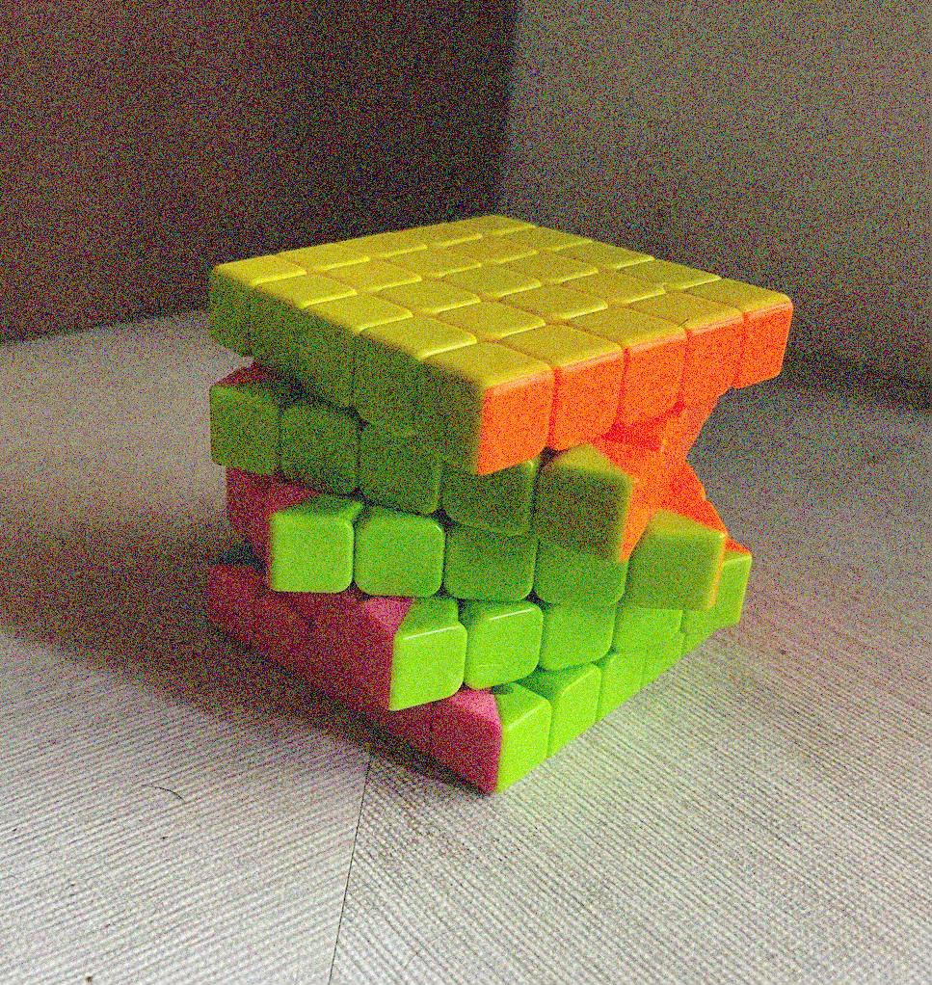

CIE ICH NOISE: WHITE MASK:

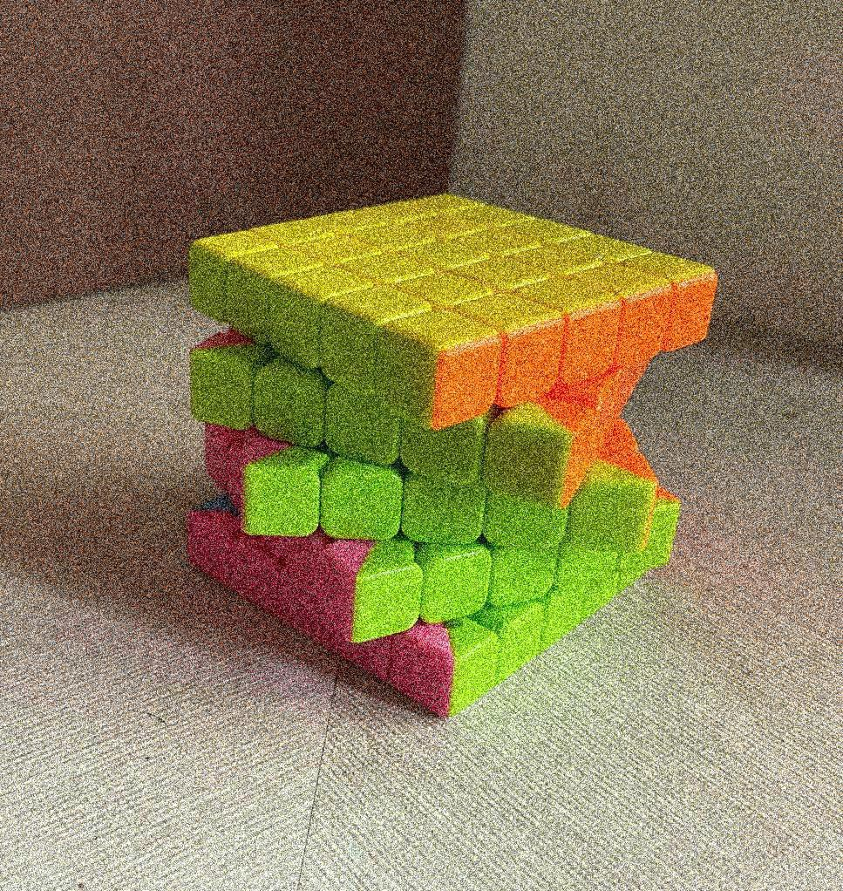

1. **ANIMATION - FRAMES**

FRAME 1 FRAME 2 FRAME 3

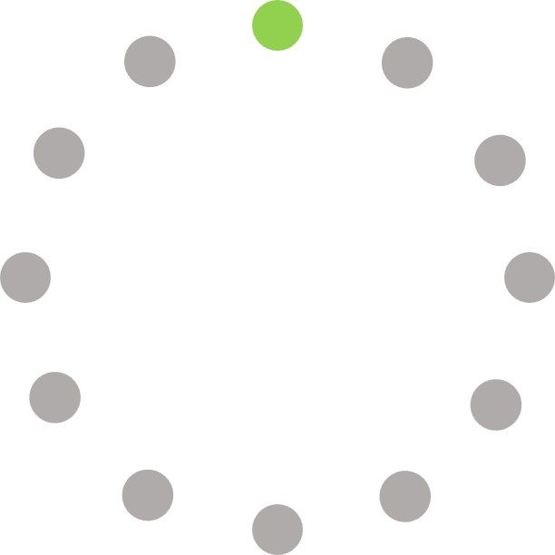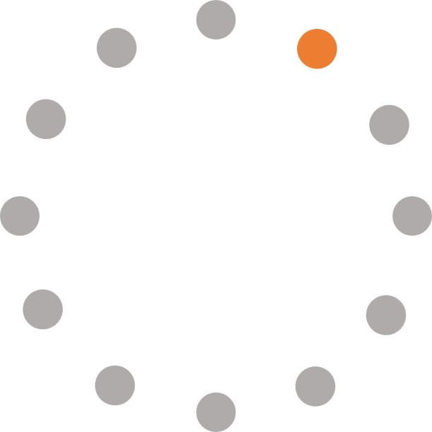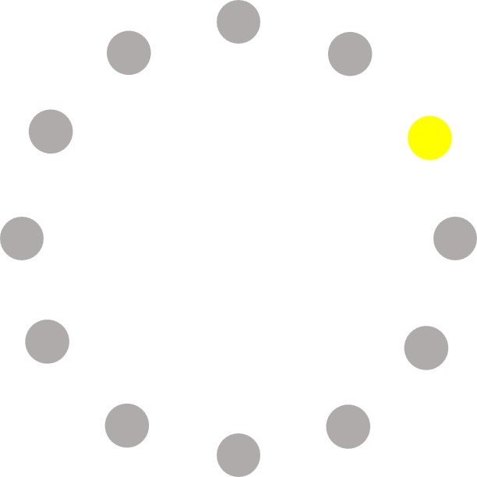

FRAME 4 FRAME 5 FRAME 6

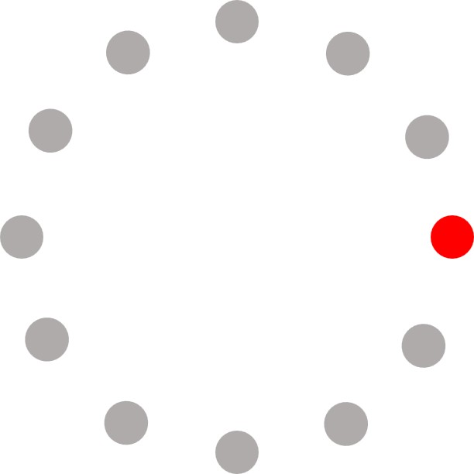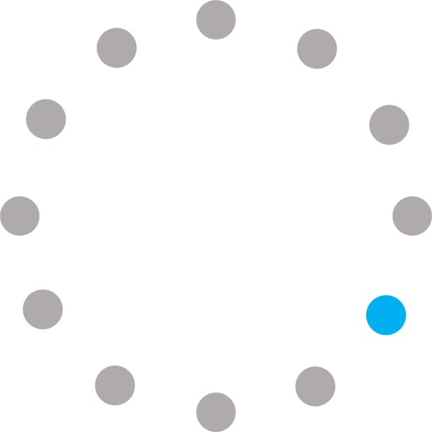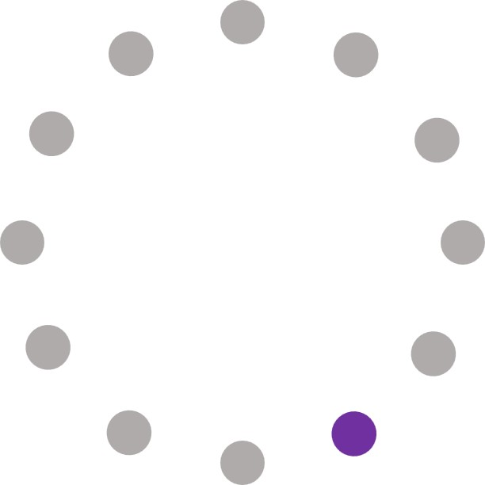

FRAME 7 FRAME 8 FRAME 9

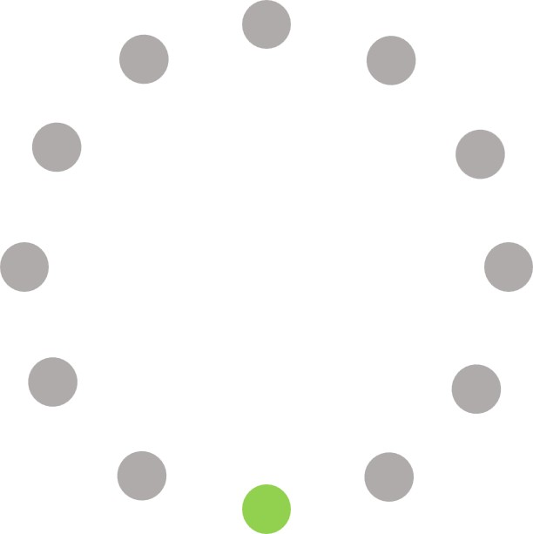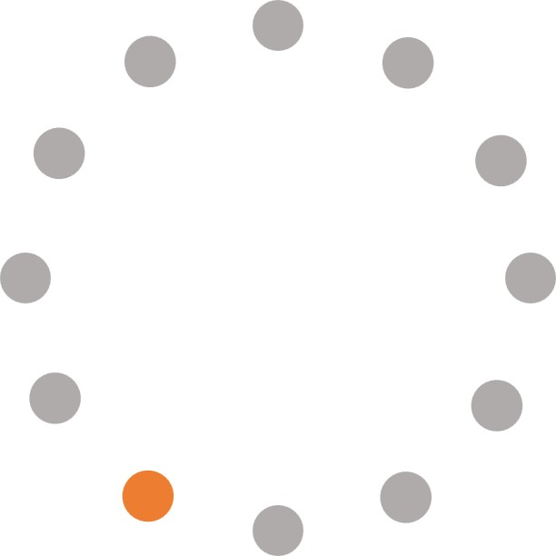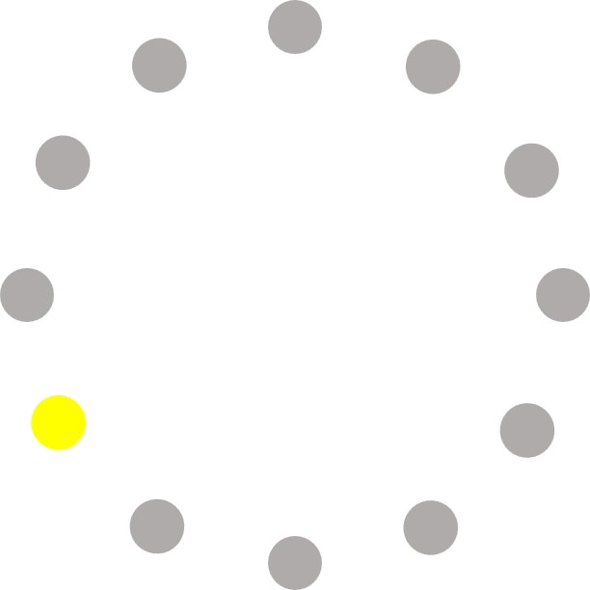

FRAME 10 FRAME 11 FRAME 12

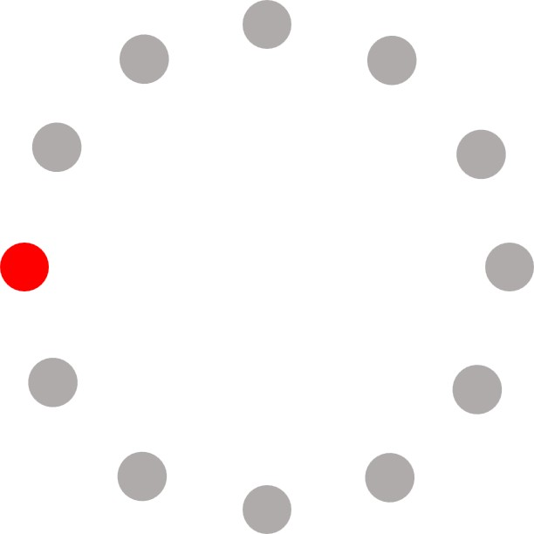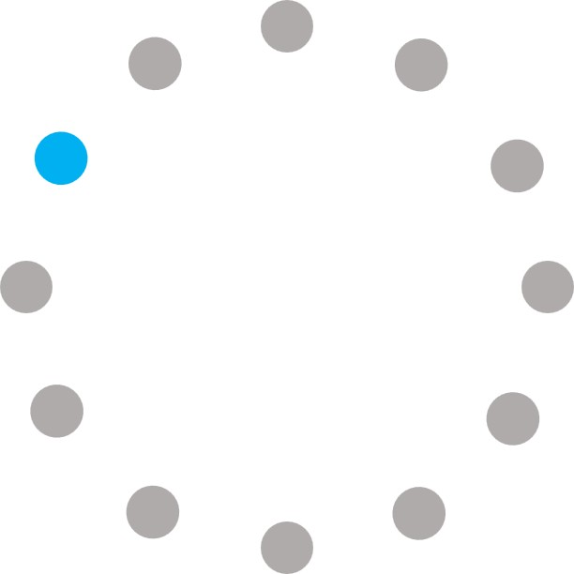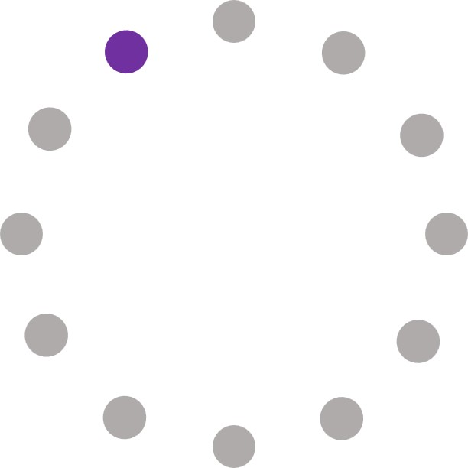

LEARNING OUTCOMES:

* 1. Learnt the various tools in GIMP
  2. Learnt to apply various filters
  3. Learnt to add noise to images
  4. Learnt to add masks on images
  5. Learnt to create a GIF animated image